First Christian Church

December 17, 2023 Marshall Missouri 10:00 AM

Minister- Rev. Randal DeMasters

Welcome Songs “Noel” and “Joy to the World” FCC Praise Band

Lighting of the Advent Candle Lori Layton & Kay Wise
Candle lighting Song The First Noel

Call to Worship

Opening Hymn “Joy To the World” Blue # 92

Joy to the world, the Lord is come, Let Earth receive her King
Let every heart prepare Him room, And Heaven and nature sing
And Heaven and nature sing, And Heaven, and Heaven, and nature sing

Joy to the Earth, the Savior reigns, Let men their songs employ
While fields and floods, rocks, hills and plains, Repeat the sounding joy
Repeat the sounding joy, Repeat, repeat, the sounding joy

He rules the world with truth and grace, And makes the nations prove
The glories of His righteousness, And wonders of His love
And wonders of His love, And wonders, wonders, of His love

Invocation and Lord’s Prayer Our Father who art in heaven, hallowed be thy name. Thy kingdom come, thy will be done, on earth as it is in heaven. Give us this day our daily bread. And forgive us our debts, as we forgive our debtors. Lead us not into temptation, but deliver us from evil. For thine is the kingdom, and the power, and the glory, forever. Amen
Invitation to Communion and Communion Prayer
Holy Communion
The celebration of the Lord’s Supper is the central focus of our faith and worship together.
All who believe in Jesus Christ are invited to partake in the sacraments.

Offering Statement/ Prayer of Dedication
Good News for the Young at Heart

Special Music “Mary Did You Know” FCC Praise Band

Sermon Rev. Sally DeMasters
Scripture Psalm 126; Isaiah 61:1-4, 8-11; John 1:6-8, 19-28

Invitation
Any person desiring to profess Jesus Christ as Lord and Savior, or to transfer their church membership to this congregation, is now invited forward.

Closing Hymn “O Little Town of Bethlehem” Blue # 96
O little town of Bethlehem, How still we see thee lie!
Above thy deep and dreamless sleep The silent stars go by.
Yet in thy dark streets shineth The everlasting Light;
The hopes and fears of all the years Are met in thee tonight.

For Christ is born of Mary And gathered all above,
While mortals sleep the Angels keep Their watch of wondering love.
O morning stars, together Proclaim the holy birth!
And praises sing to God the King, And peace to men on earth.

How silently, how silently, The wondrous gift is given
So God imparts to human hearts The blessings of His Heaven.
No ear may hear His coming, But in this world of sin
Where meek souls will receive Him still, The dear Christ enters in.

Benediction

CHURCH ANNOUNCEMENTS
Please take a moment to think of our members who are unable to attend or have not attended our services lately, and send them a card or note. This week, consider sending your thoughts and prayers to Amanda McCord. You can mail them directly to the following address:
C/O Westport Assisted Living 906 Apache Drive #B6 Marshall, MO 65240

The Congregational meeting, to approve the new budget will be today. This brief meeting will take place immediately following the 10:00 worship service.

A big thank you to those who have brought in items to help with our Christmas packages for individuals in nursing homes who will not have family or visitors this year. We are still in need of “filler” trinkets/candy to fill their bags! If you have anything you would like to give, please bring it by the Church tomorrow. After that, we will shop for needed items with the generous donations we have received. From the Worship Committee…we thank you.

Our Church is signed up to “ring the bells” on December 18th from Noon-8:00 PM in front of Wal-Mart. Only one spot has been filled!! The sign-up sheet is in the Parlor, for those who are willing and able to give an hour of their time.

If you would like to remember a loved one with a Poinsettia displayed this year, please have them in the Church office between December 18-20. If you would like them back, they will be available for pick-up after December 27th.

Jo Wilhite will turn 102 on December 27th. The family has requested a card shower to celebrate her special day. They have requested cards be sent to:
C/O Michael Wilhite 8276 W 116th Overland Park KS 66209

If you would like to give to the Christmas Offering, simply place a check in the offering plate and put “Christmas Offering” in the memo. Or, place cash or a check in an envelope, located in the pew, and write “ Christmas Offering on the outside before placing in the offering plate.

BIRTHDAYS
12/18 Karolyn Caldwell 12/21 Emily Kueker 12/22 Linda Dryer
12/20 Jill Buck 12/22 Leslie Coslet 12/23 Amanda McCord
12/20 Meg Kissner

ANNIVERSARIES
12/17 Paul & Michelle Scarf 12/23 Todd & Christy Marshall

PRAYER LIST
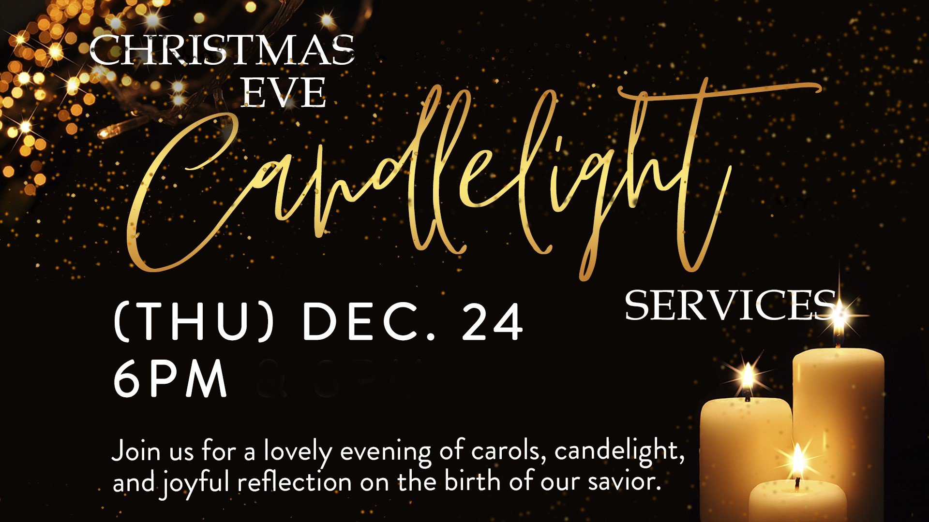
Ayden Wright Helen Merchant Alisa Smith Shirley Kueker Pat Krause Brad Berlin Vic Hessel Jo Nell Fizer
Christi Snider Norman Gibbins Cody Samson Dan Brandt
JoDell Alexander Tara Jackson Beth LaGore Rosie Bentley
Tom McRoberts Spencer Fricke

Attendance: December 10, 2023 Please take a moment to fill out our Attendance
10:00 Worship: 72 Registration that is located in a blue folder in each pew seat.

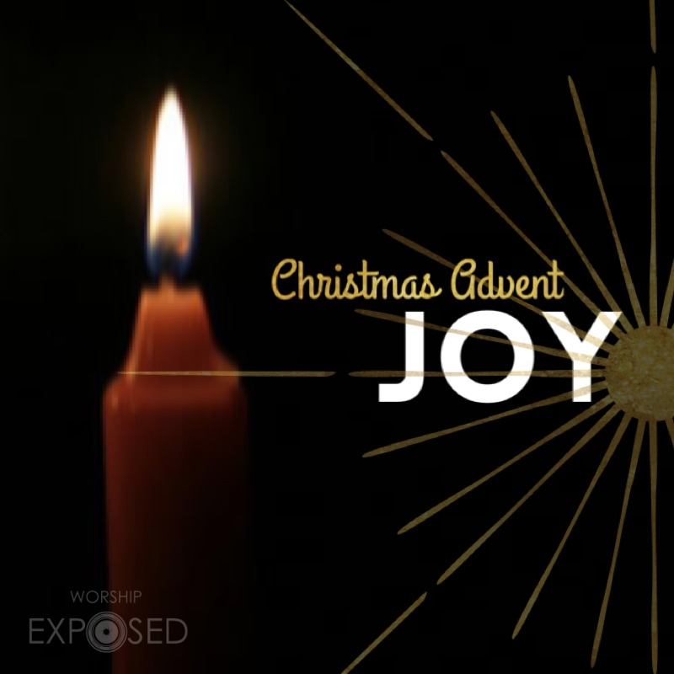


For those who wish to
give offering, an offering
plate/box has been placed on
tables in the Sunroom and entryway into the Sanctuary.
You may also give online via “Givelify”. Thank you
for coming today.

