First Christian Church

May 07, 2023 Marshall Missouri 10:00 AM

Minister- Rev. Randal DeMasters

Welcome Song “River of Life” FCC Praise Band

Welcome and Announcements Sharae Kelley
Call to Worship

Opening Hymn “What A Wonderful Change in My Life” Blue # 287

What a wonderful change in my life has been wrought, Since Jesus came into my heart;
I have light in my soul for which long I have sought, Since Jesus came into my heart.

Since Jesus came into my heart, Since Jesus came into my heart;
Floods of joy o’er my soul like the sea billows roll, Since Jesus came into my heart.

I have ceased from my wand’ring and going astray, Since Jesus came into my heart;
And my sins which were many are all washed away, Since Jesus came into my heart.

Since Jesus came into my heart, Since Jesus came into my heart;
Floods of joy o’er my soul like the sea billows roll, Since Jesus came into my heart.

Invocation and Lord’s Prayer Our Father who art in heaven, hallowed be thy name. Thy kingdom come, thy will be done, on earth as it is in heaven. Give us this day our daily bread. And forgive us our debts, as we forgive our debtors. Lead us not into temptation, but deliver us from evil. For thine is the kingdom, and the power, and the glory, forever. Amen
Invitation to Communion and Communion Prayer
Holy Communion
The celebration of the Lord’s Supper is the central focus of our faith and worship together.
All who believe in Jesus Christ are invited to partake in the sacraments.

Offering Statement/ Prayer of Dedication
Good News for the Young at Heart

Special Music “Nobody” FCC Praise Band

Sermon Rev. Randal DeMasters
Scripture 1 Peter 2:2-10, John 14: 1-14

Invitation
Any person desiring to profess Jesus Christ as Lord and Savior, or to transfer their church membership to this congregation, is now invited forward.

Closing Hymn “Shout to the Lord” PowerPoint
My Jesus, my Saviour, Lord there is none like You
All of my days I want to praise, The wonders of Your mighty love
My comfort, my shelter, Tower of refuge and strength
Let every breath, all that I am, Never cease to worship You

Shout to the Lord all the Earth, let us sing, Power and majesty, praise to the King
Mountains bow down and the seas will roar At the sound of Your name
I sing for joy at the work of Your hands, Forever I'll love You, forever I'll stand
Nothing compares to the promise I have In You.

[ repeat all]

Nothing compares to the promise I have.
Nothing compares to the promise I have
Nothing compares to the promise I have In You.

Benediction

CHURCH ANNOUNCEMENTS
Please take a moment to think of our members who are unable to attend or have not attended our services lately, and send them a card or note. This week, consider sending your thoughts and prayers to Amanda McCord. You can mail them directly to the following address:
Cedarhurst Independent and Assisted Living 3751 W. 10th room # 123 Sedalia, MO 65301

The Fellowship Committee will host a Church Dinner today following the Church service. Everyone is welcome to attend!

Our May General Board meeting will be on Wednesday the 10th at 6:00 pm. We hope to see you there.

Get geared up! Drive-Up Services will start back Memorial Day weekend, May 28th. The outdoor service will begin at 8:00am.

BIRTHDAYS
05/08 Ginger McGraw 05/10 Lori Blalock 05/12 Alan Branson
05/09 Lin Alexander 05/10 Janice Kueker 05/13 Ruth Marsh
05/09 Kara Clark 05/10 Lisa Merchant

ANNIVERSARIES
05/11 Jim & Lisa Merchant

PRAYER LIST
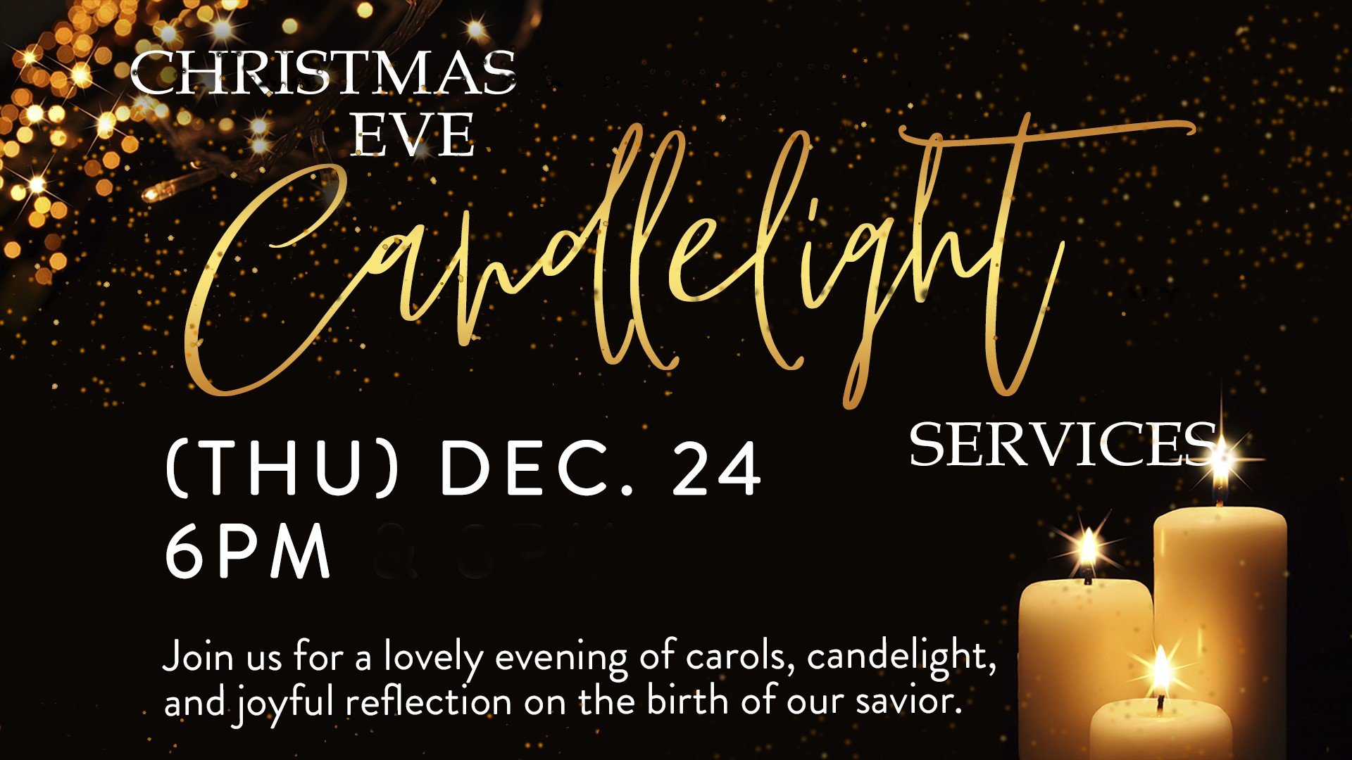
Ayden Wright Helen Merchant Alisa Smith Shirley Kueker Pat Krause Brad Berlin Vic Hessel Jo Nell Fizer
Joe Palen Jr. Christi Snider Norman Gibbins Cody Samson
JoDell Alexander

Attendance: April 30, 2023
10:00 Worship: 76 Please take a moment to fill out our Attendance
Total: 76 Registration that is located in a blue folder in each pew seat.

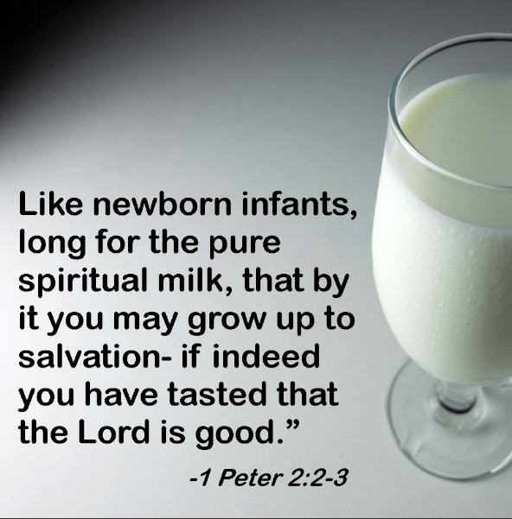



For those who wish
to give offering, an
offering plate/box has
been placed on tables in the Sunroom
and entryway into the Sanctuary. You
may also give online via “Givelify”.
Thank you for coming today.

